Overview of the Kentucky Business One Stop Portal

Disclaimer
The information in this manual is for educational and informational purposes only and does not constitute legal advice. Information is presented as an overall review that is subject to law changes and may not apply to all states.
Information in this manual is believed to be accurate as of the date of publication. In the event that any information in this manual is later determined to be in error, this manual cannot be used by taxpayers in supporting a specific position or issue before the Department of Revenue, as it does not have the statutory or regulatory authority.

Overview of the Kentucky
Business One Stop Portal
(Updated 7/31/19)

Once logged into your user account, the businesses that you have registered or linked will be under the ‘My businesses’ tab. Click on a business you would like to manage. At any time, you can select the One Stop logo in the top left hand corner and this link will take you back to the Dashboard.

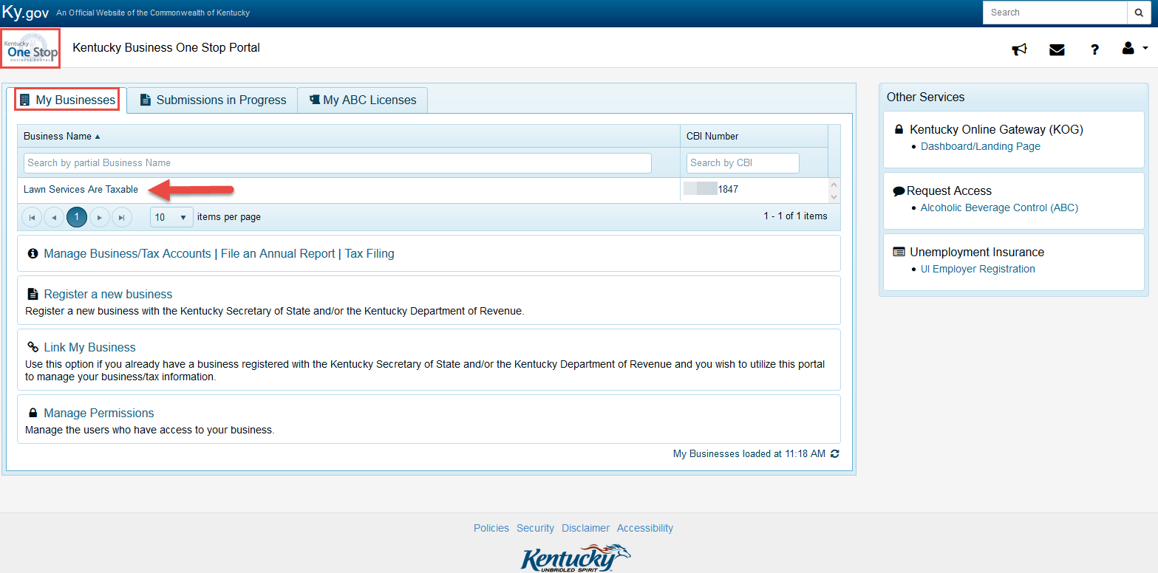

After selecting the business the user wants to manage, they will be taken to their business-landing page. The business-landing page can be slightly different depending on which state agencies the business is registered with. This is because each agency that utilizes KYBOS has its own tab. In the example below, you will see that the fictitious business is registered with the KY SOS and the KY DOR.

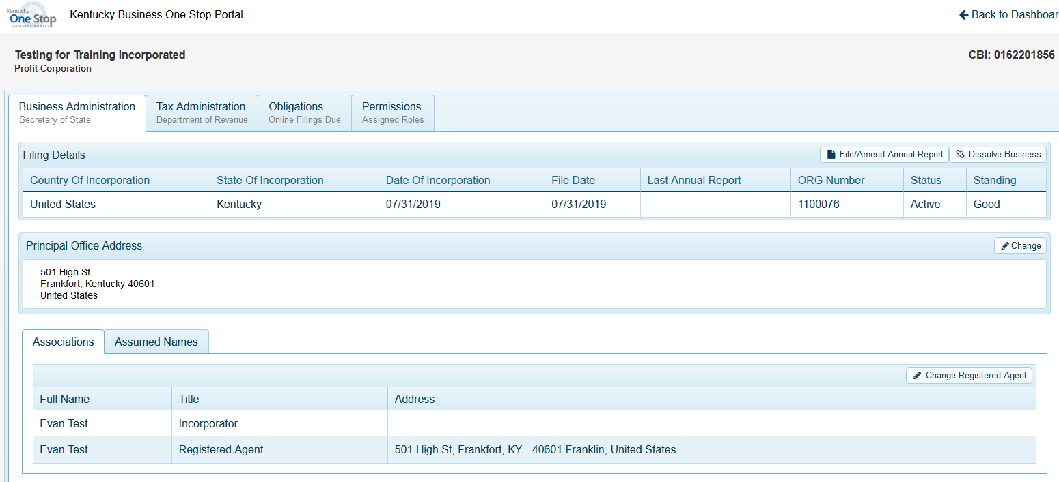

If the business is registered with the Kentucky Secretary of State, the first tab displayed is the ‘Business Administration’ tab. This is the KY SOS information for the business. The CBI # is displayed in the top right hand corner. The State of Inc., Date of Inc., File Date, and ORG # are center screen. With the Principle Office address to the left and the business’ Associations and Assumed Names at the bottom.

Users will be able to File/Amend Annual Reports, Dissolve their business, change their Principle Office Address, change their Registered Agent, and manage their Assumed Names.

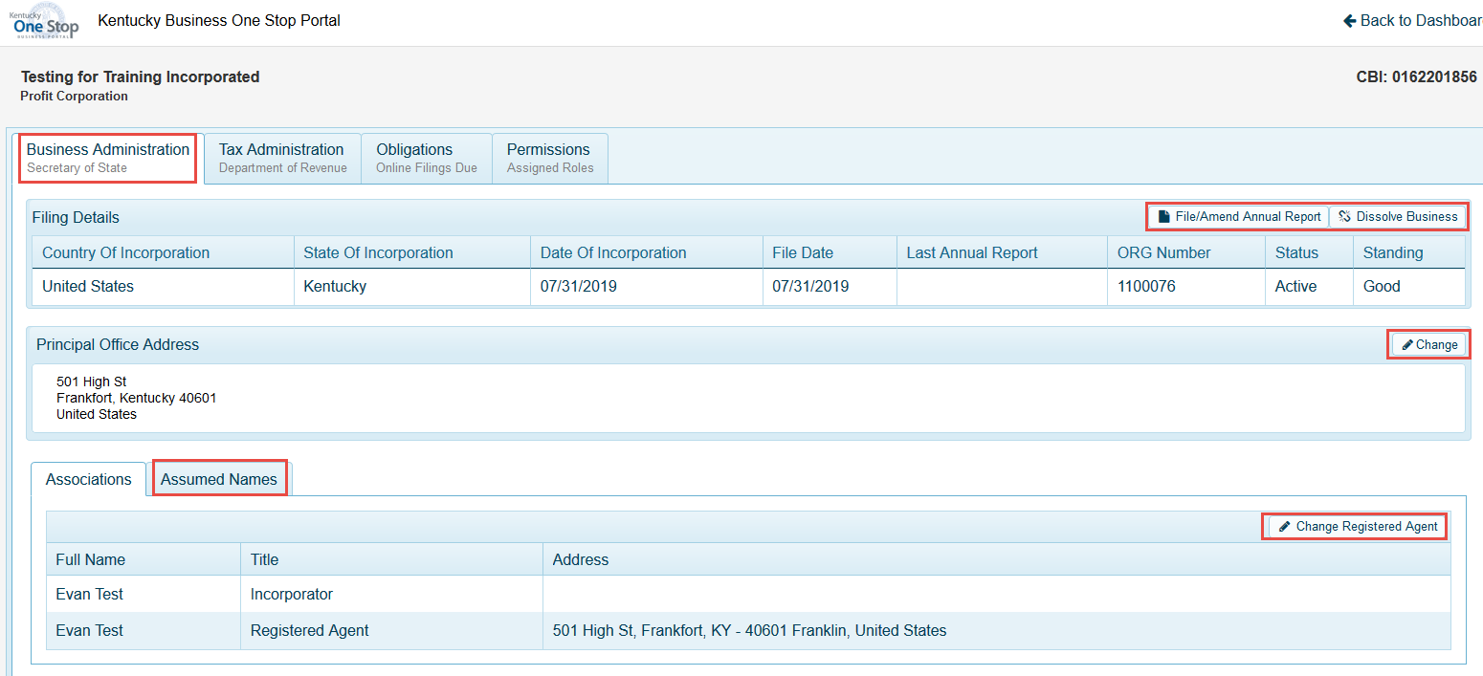

If the business is registered with the Kentucky Department of Revenue, their tax information will be under the ‘Tax Administration’ tab. In the Details window, the user will see the Taxing Election, FEIN, Accounting Method/Period, and the Accounting Period End Date. Below are three sub tabs, Tax Accounts, Responsible Parties, and Cigarette/Tobacco Products Licenses.

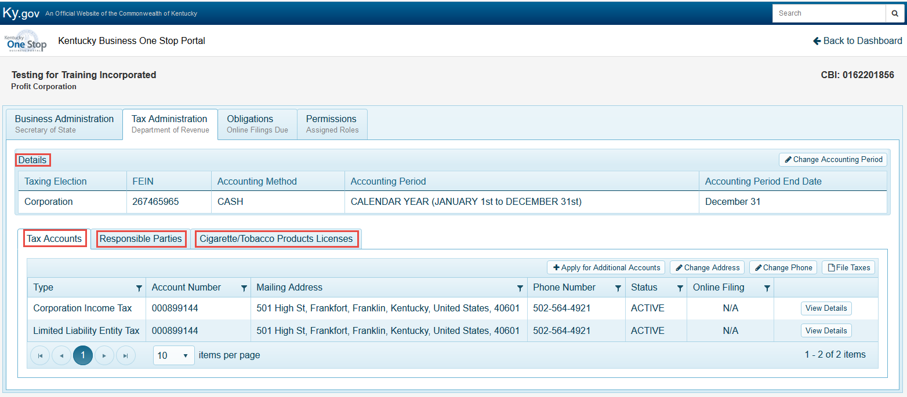

Within the Details window, the user can only edit the Accounting Period. Any other changes to information in the Details window must be made with a 10A104.
(If the business does not have an FEIN on file, the user can add an FEIN. Once it’s added, it cannot be externally deleted or updated.)

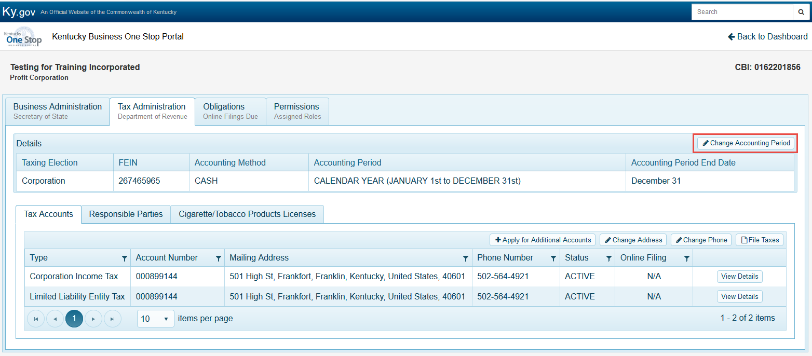

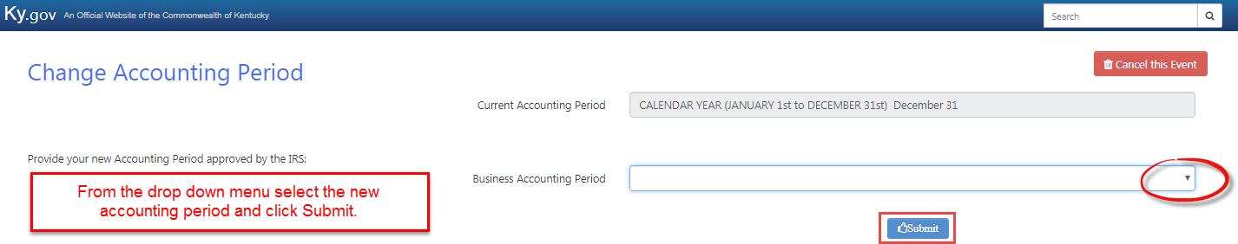

The Business’ tax account information will be displayed within the Tax Accounts sub tab. This tab will include the Tax Type, Account Number, Mailing Address, Phone Number, Status, and Online Filing status. Many of these items can be maintenance by the taxpayer.

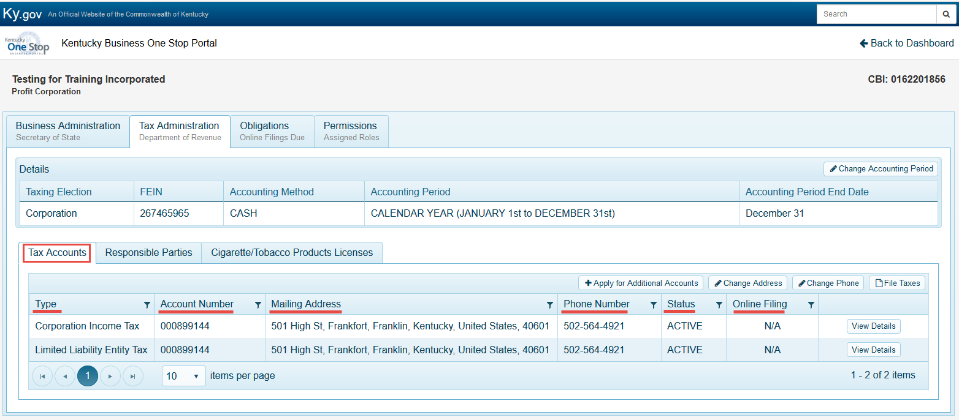

Once a business is registered. If the user needs to apply for additional accounts. They can click on the ‘Apply for Additional Accounts’ button.

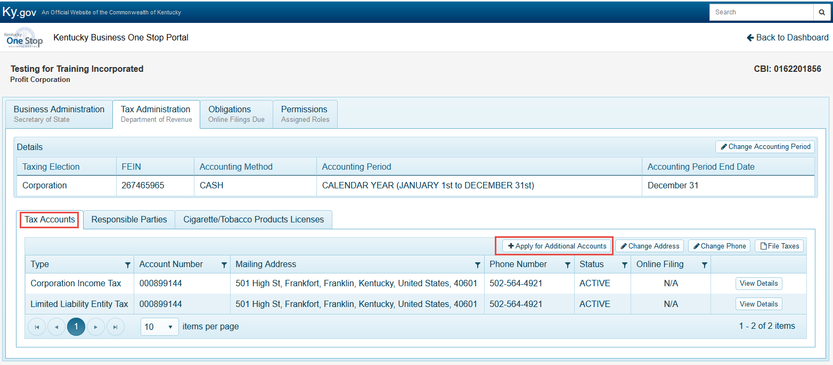

Once the user selects ‘Apply for Additional Accounts’ the user will be taken to a new page where they will begin to answer questions regarding the account they wish to add.

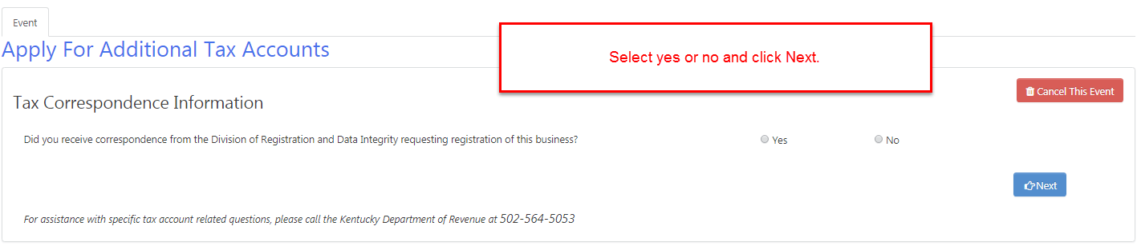

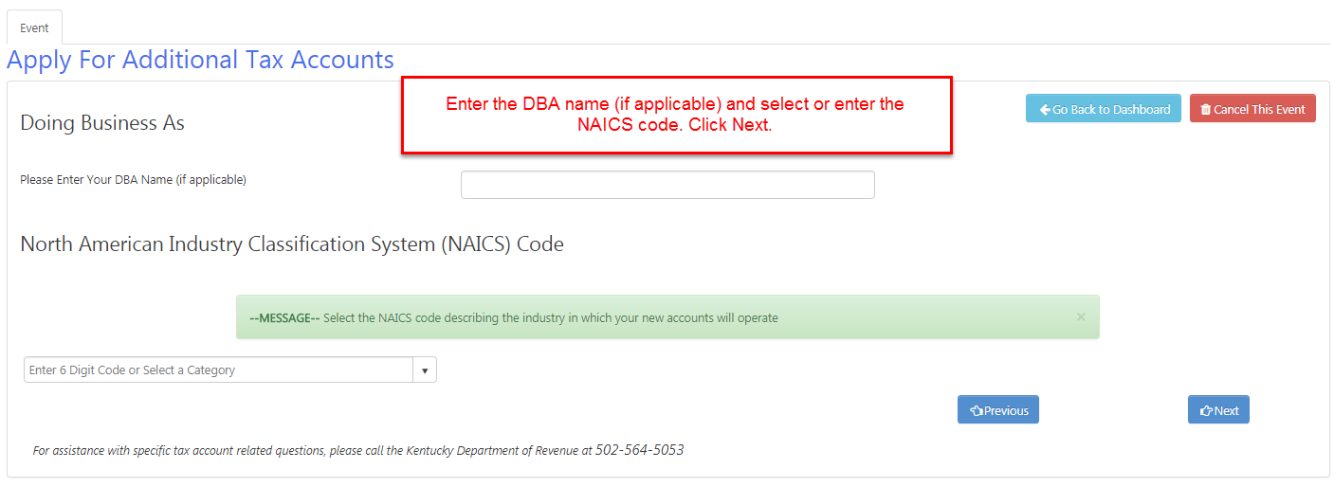

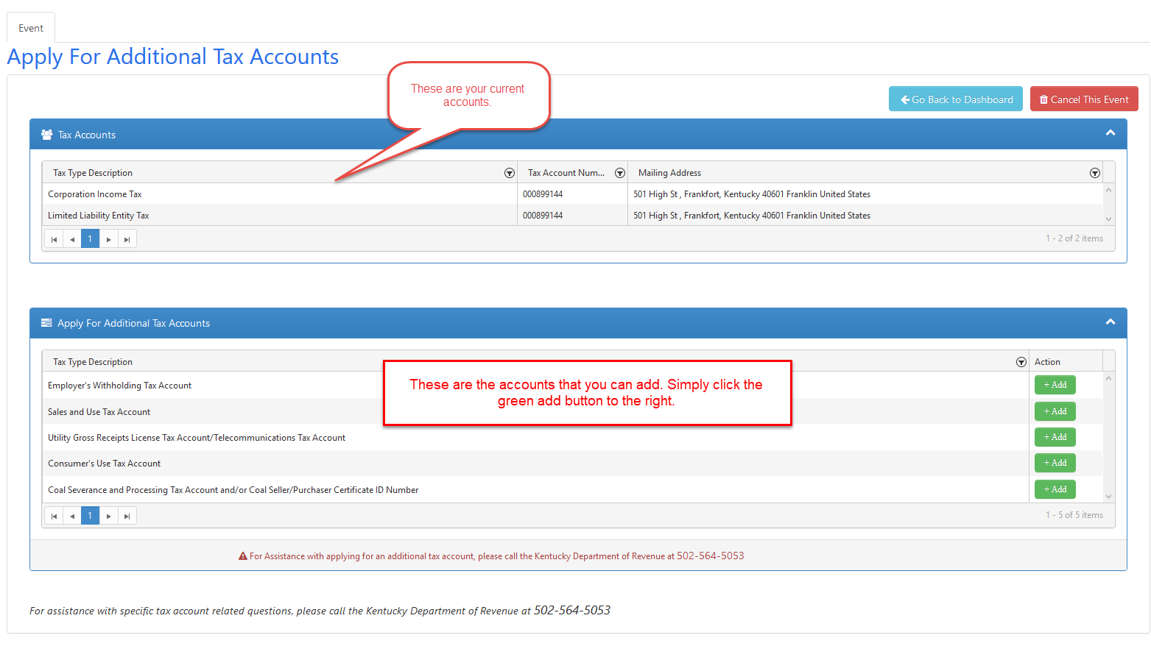
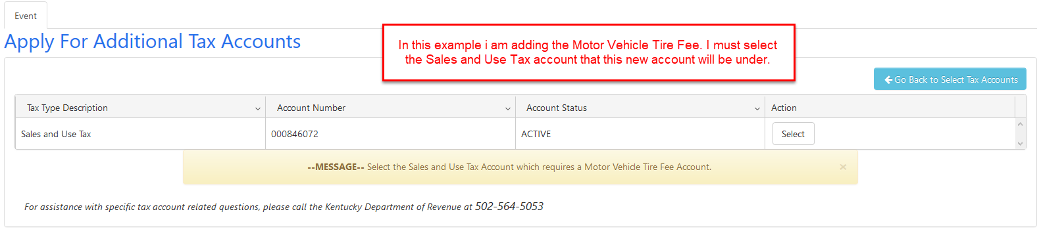
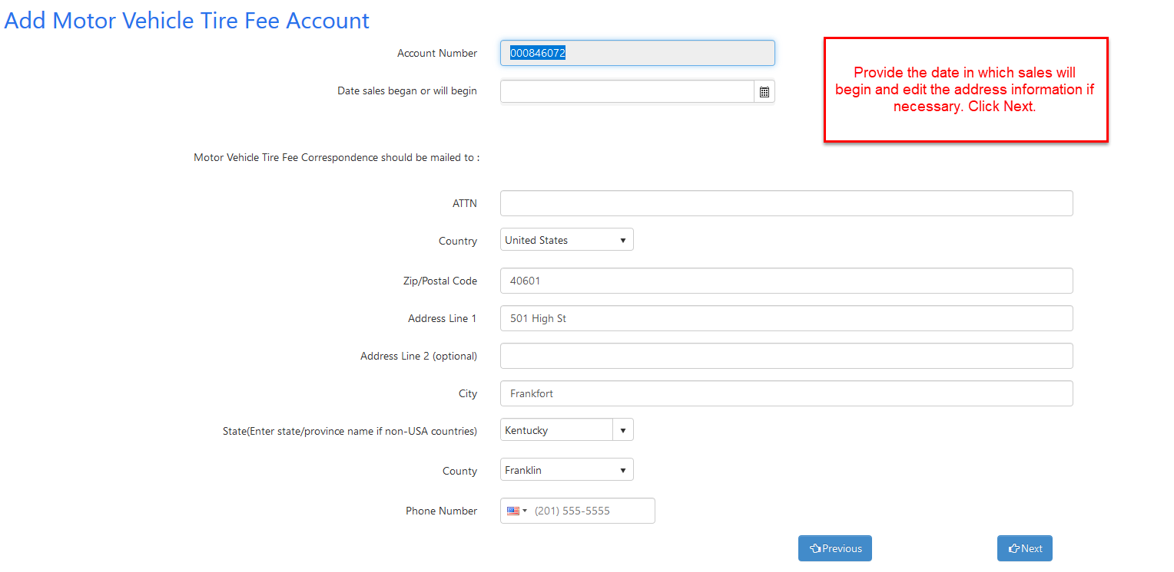
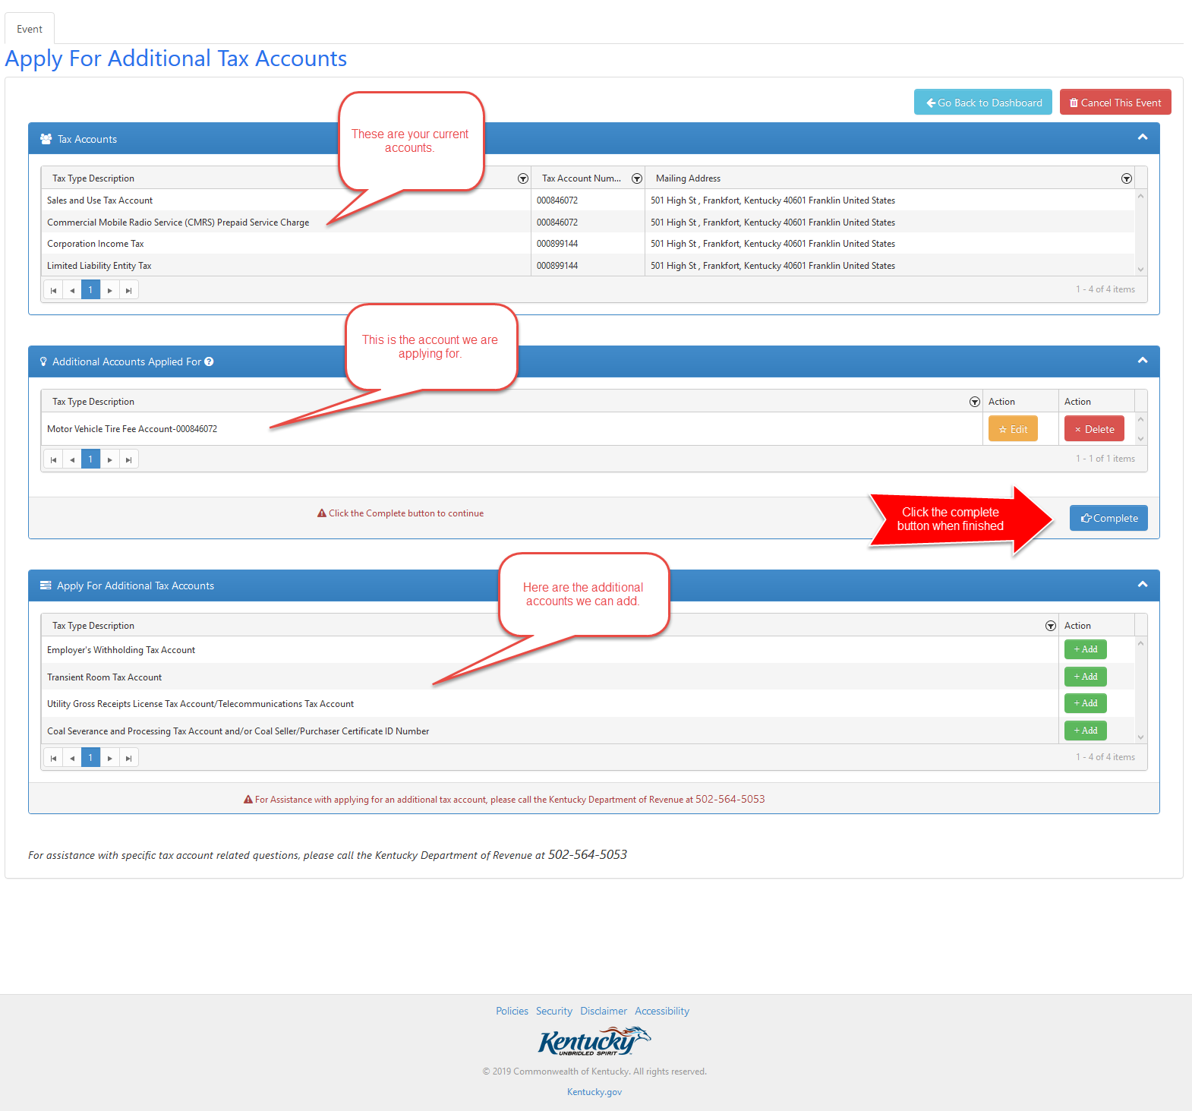
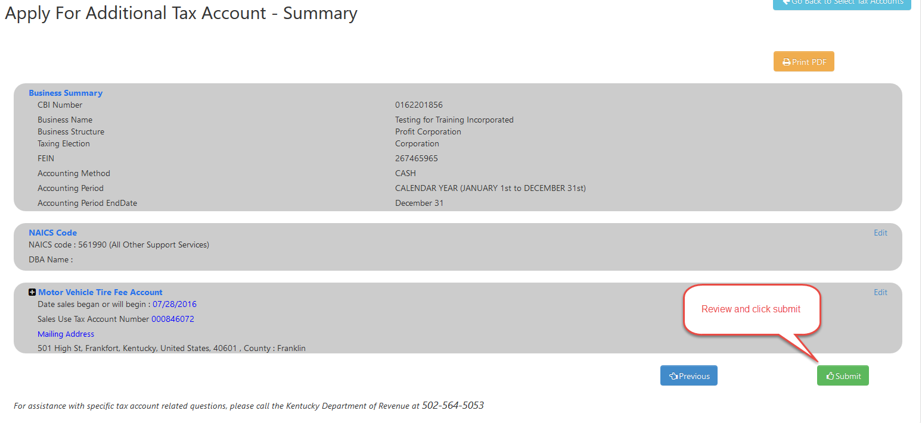

If the user would like to update their mailing address for one or multiple accounts at the same time, they can click on the ‘Change Address’ button.

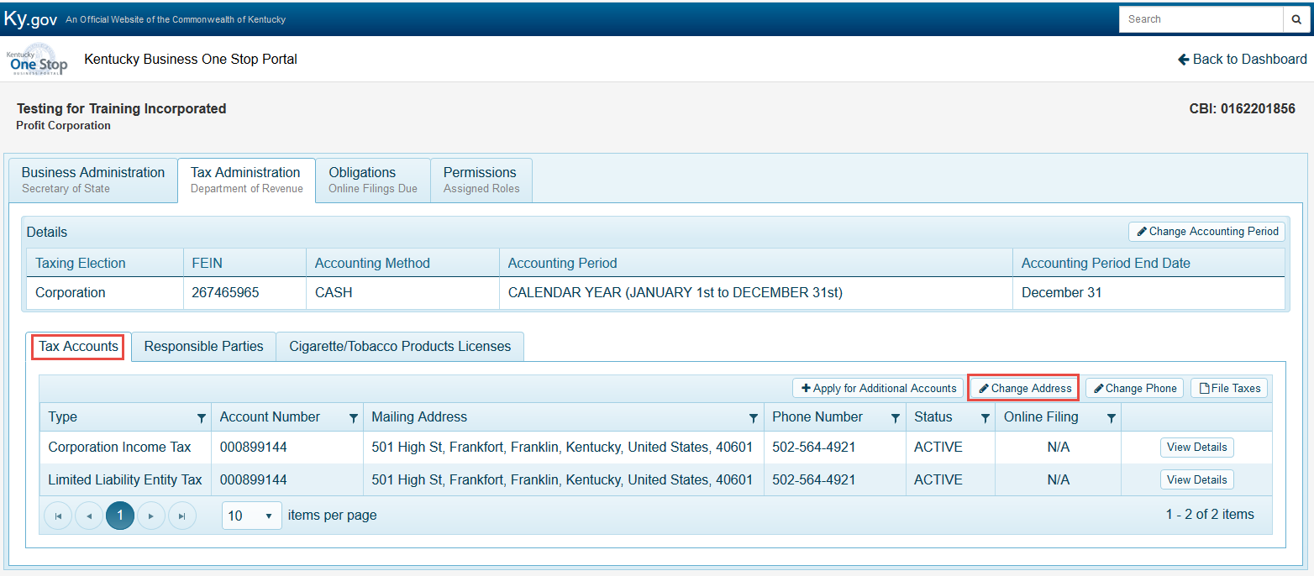
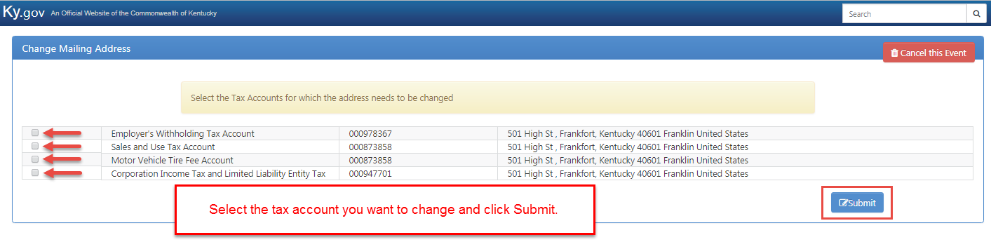
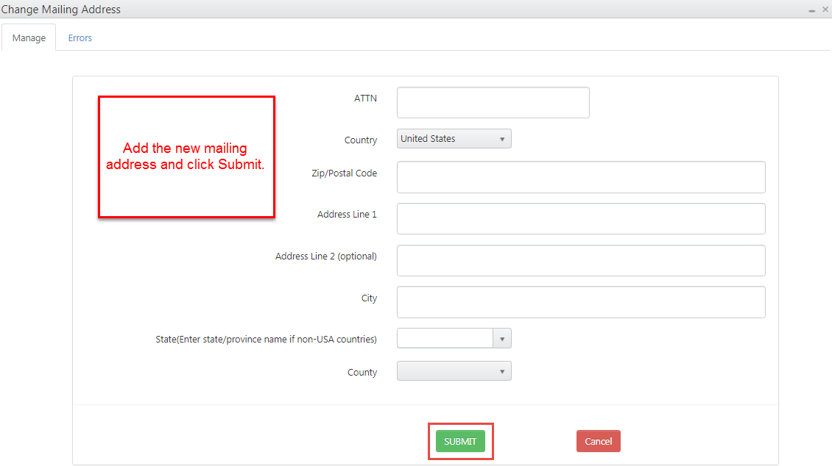

If the user would like to update their phone number on one or multiple accounts at the same time, they can click on the ‘Change Phone’ button.

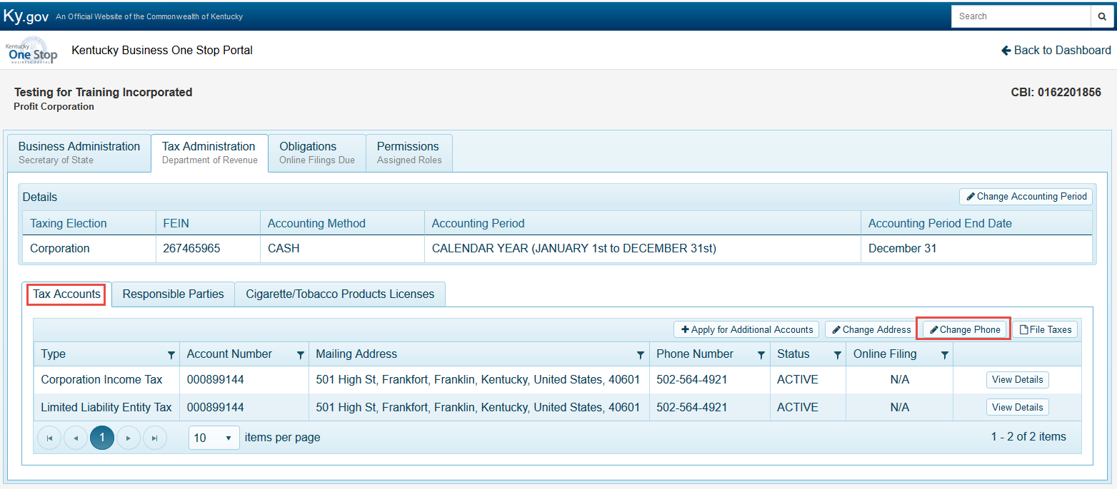

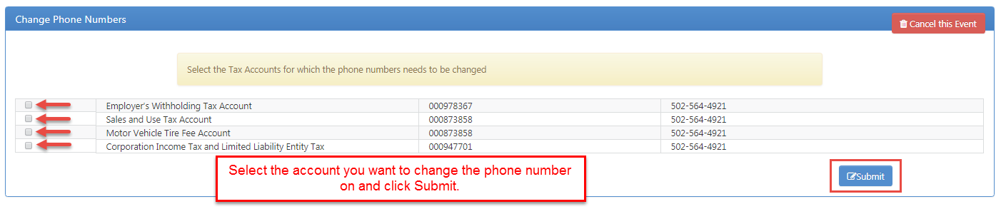
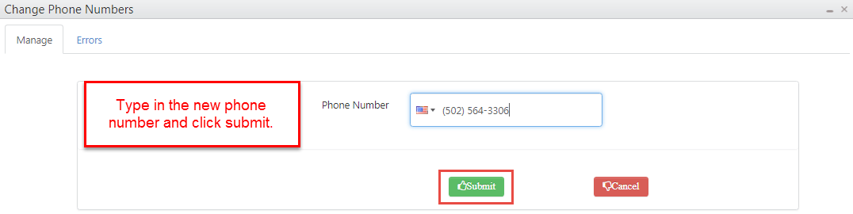

If the user would like to file their Sales, Consumers, Transient, or Tire taxes, they can click on the ‘File Taxes’ button and they will be taken to the E-File page.
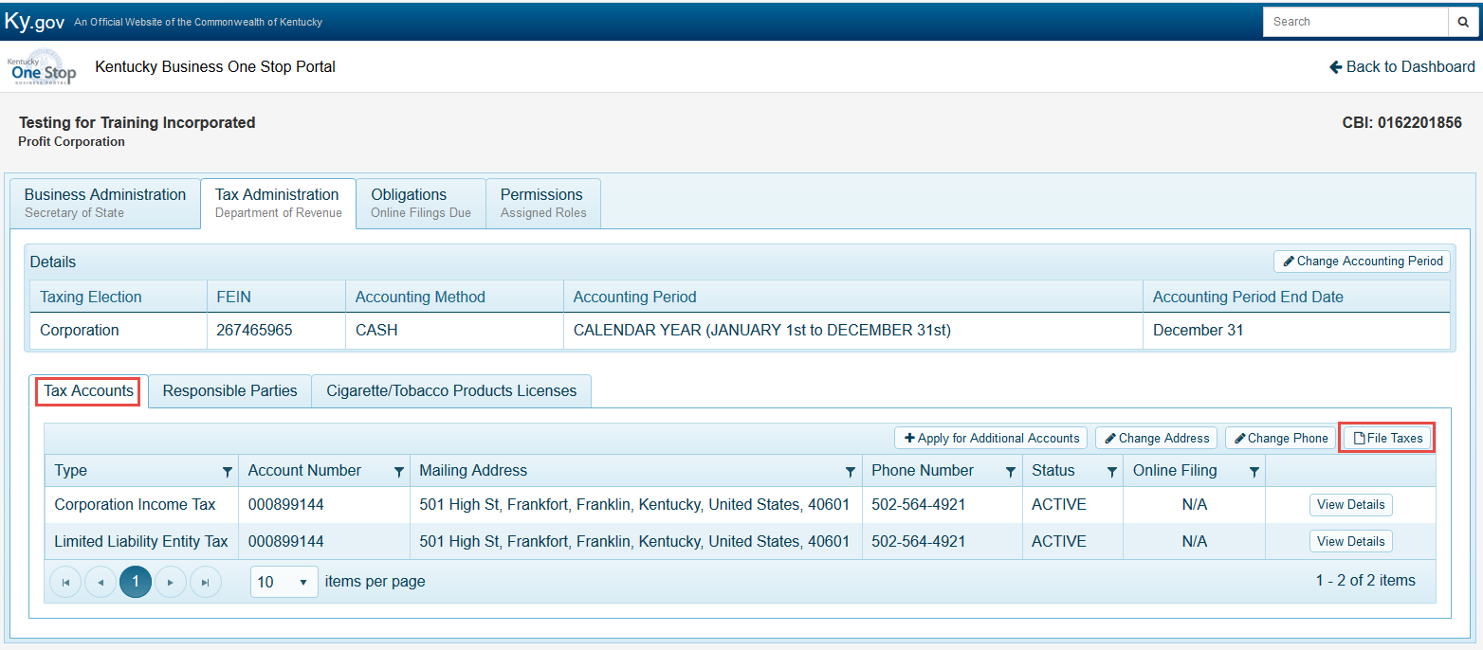

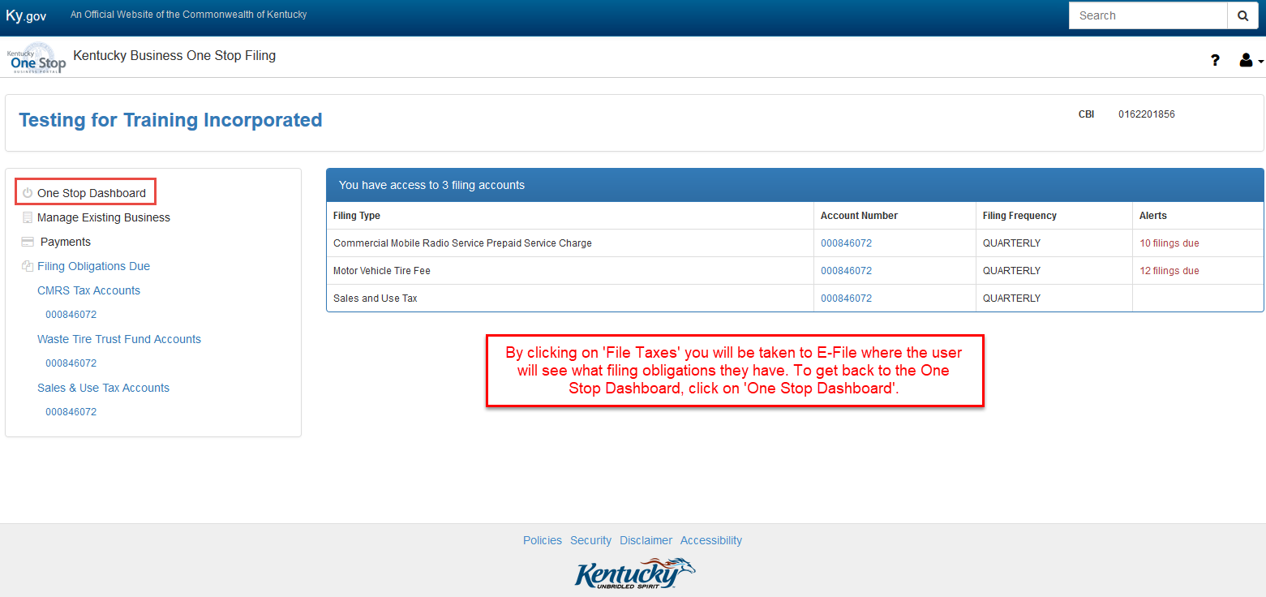

To view a specific tax account, simply click on ‘View Details’ for the specific tax account you wish to view or manage.

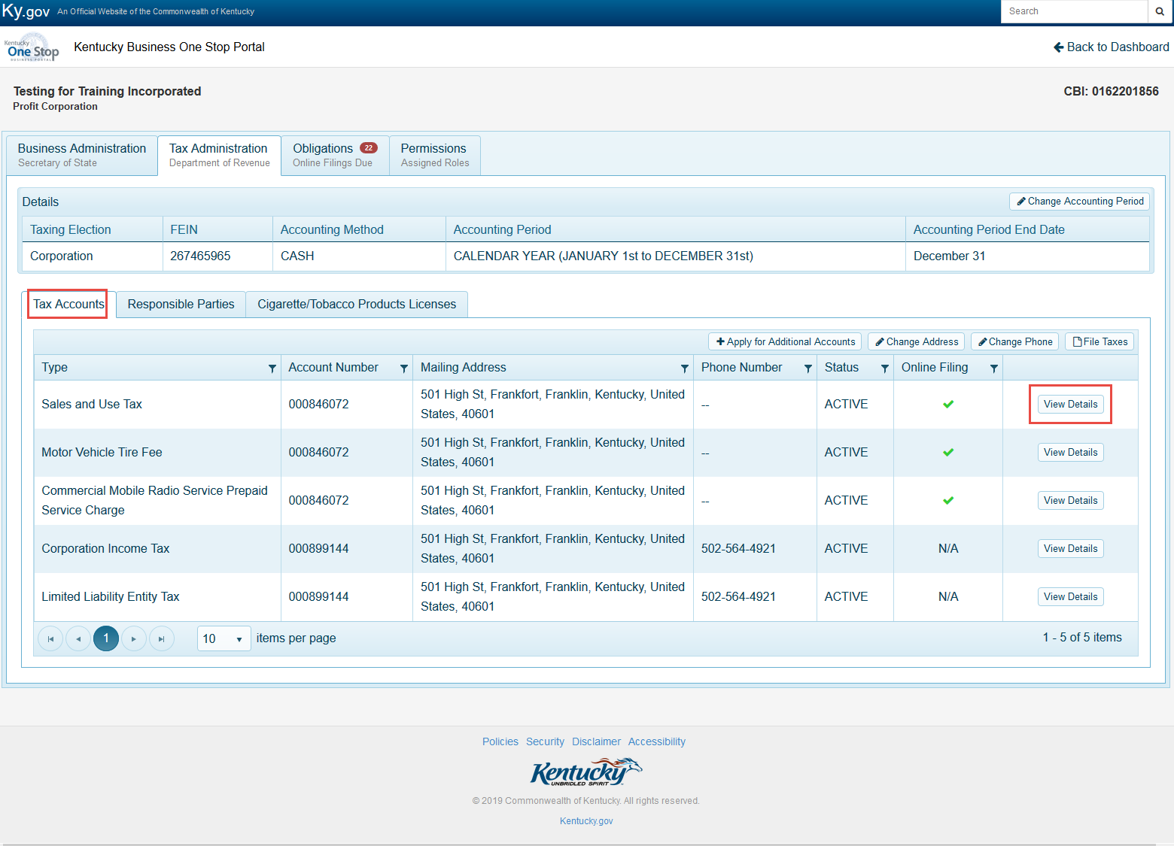

For this example, we will view the Sales and Use Tax account.

After you have clicked ‘View Details’, the Sales and Use tax account information will be displayed, including the Business Location addresses, which are located at the bottom of the page.

Within the Sales and Use tax account under ‘Business Locations’ you will see the button ‘Print Permit’.

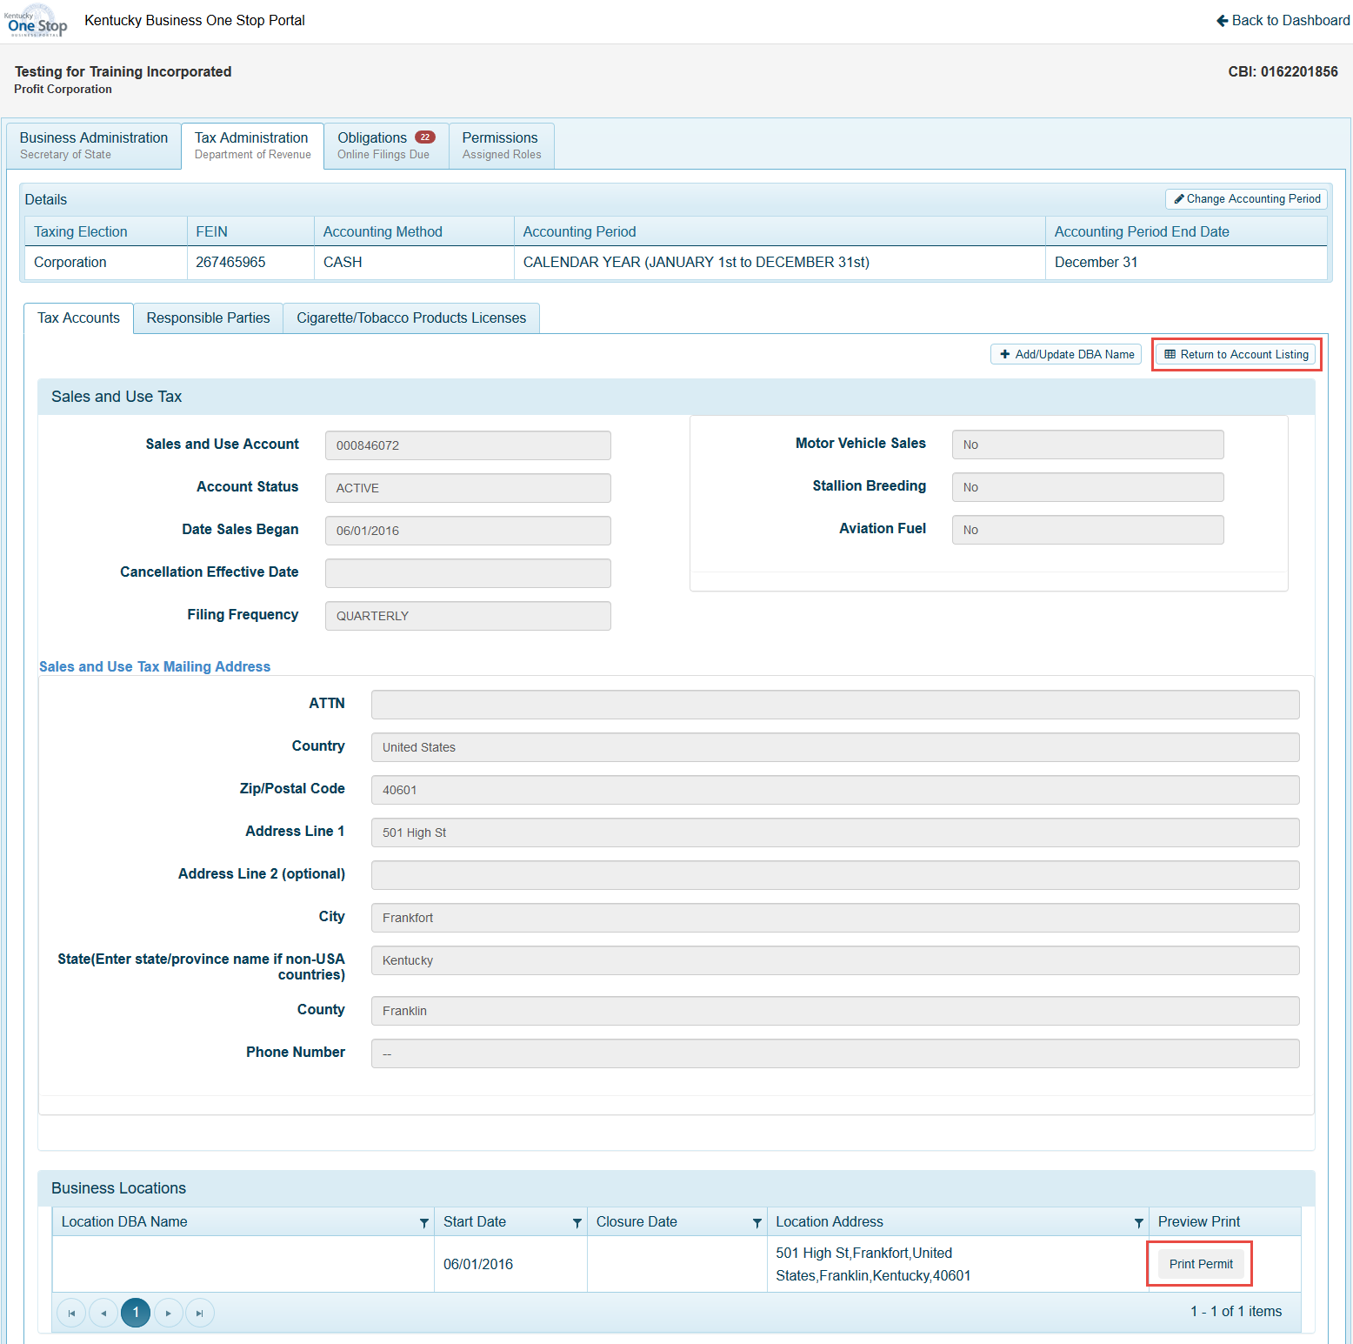

To return to the main tax account page, click ‘Return to Account Listing’.

To view the responsible parties for the business, click on the ‘Responsible Parties’ tab. This tab will display the RP Name, FEIN/SSN, Title, and Effective Date. Users will also have the ability to view the RP details and manage the RP details.

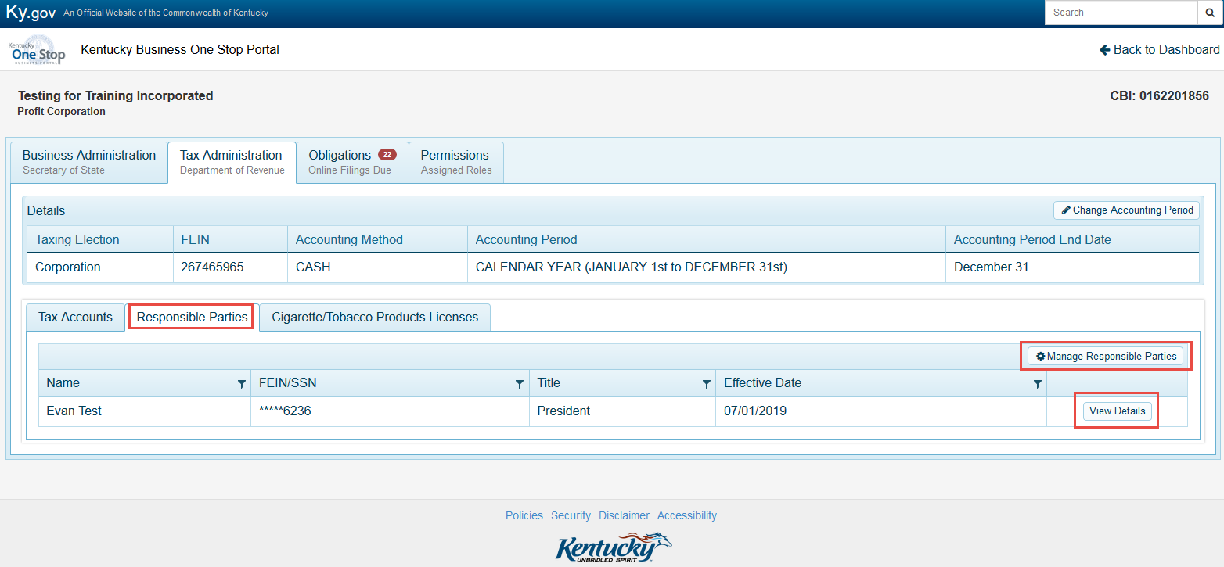

To manage the RP details, Click on the ‘Manage Responsible Parties’ button. Depending on how the business is structured and taxed will determine what information the user can edit.

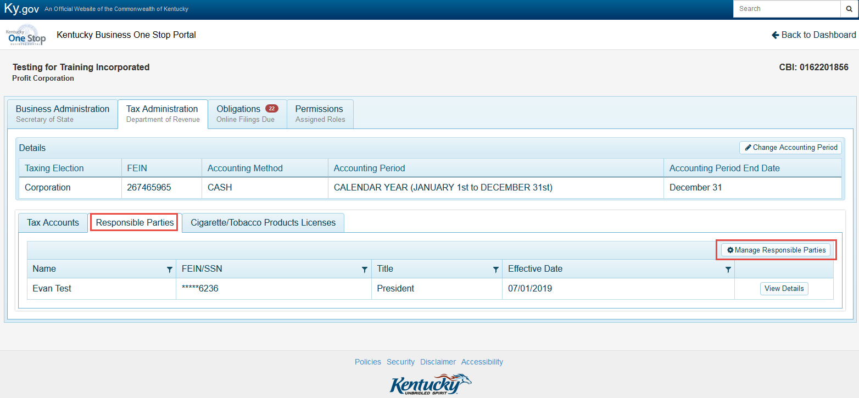

To edit the responsible parties’ information, click on the ‘Edit’ button.

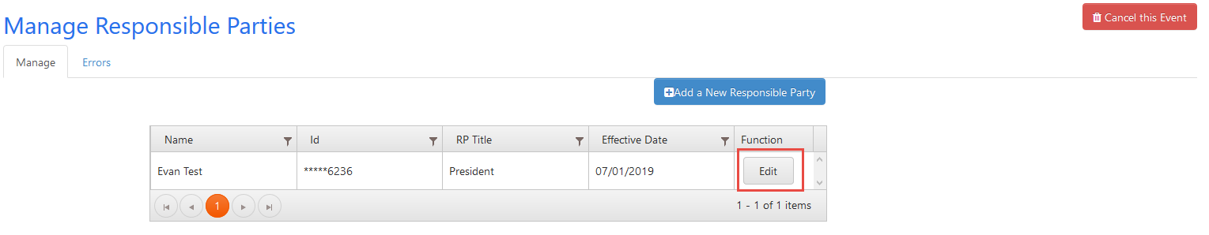
From the drop down menu, the user will have the option to add an additional title for the RP already on file, or change the RP address and phone number. (Externally, you cannot update an RP’s SSN or FEIN.)

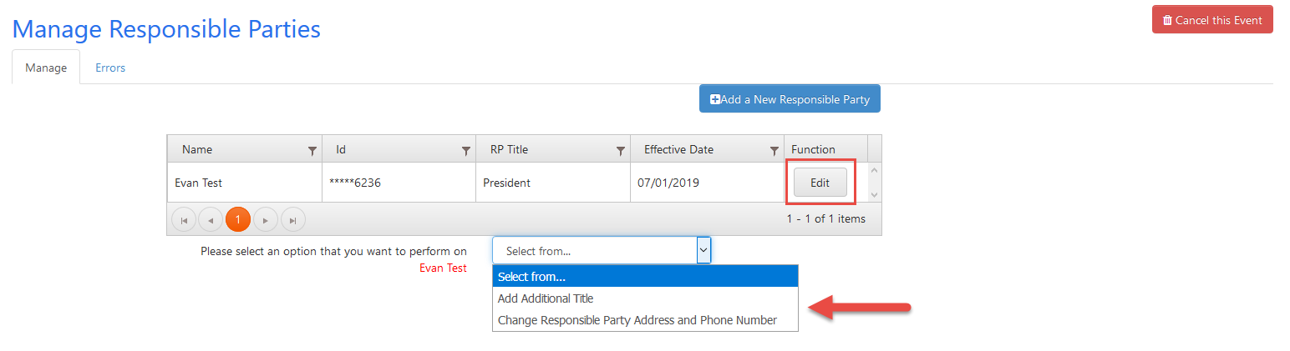

Adding an additional title: Select which title you would like to assign to the RP, select the effective date and then click submit.

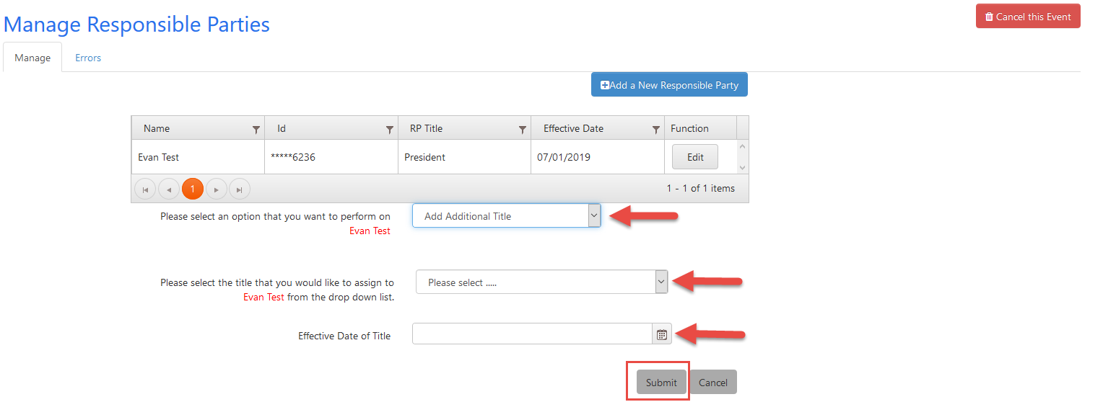
Change Responsible Party Address/Phone number: Update the RP information and click update.

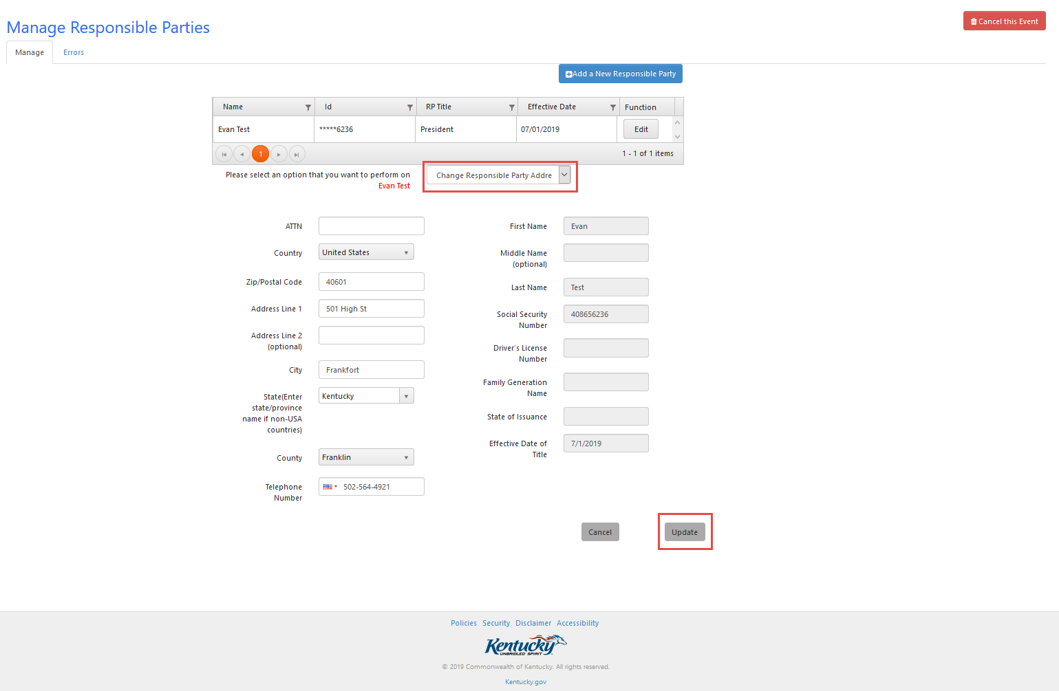

Users may have the option to add an additional responsible party. To add a New Responsible Party, click on the ‘Add a New Responsible Party’ button. Once they have entered the new RP’s information, click ‘Add Responsible Party’ at the bottom of the page.

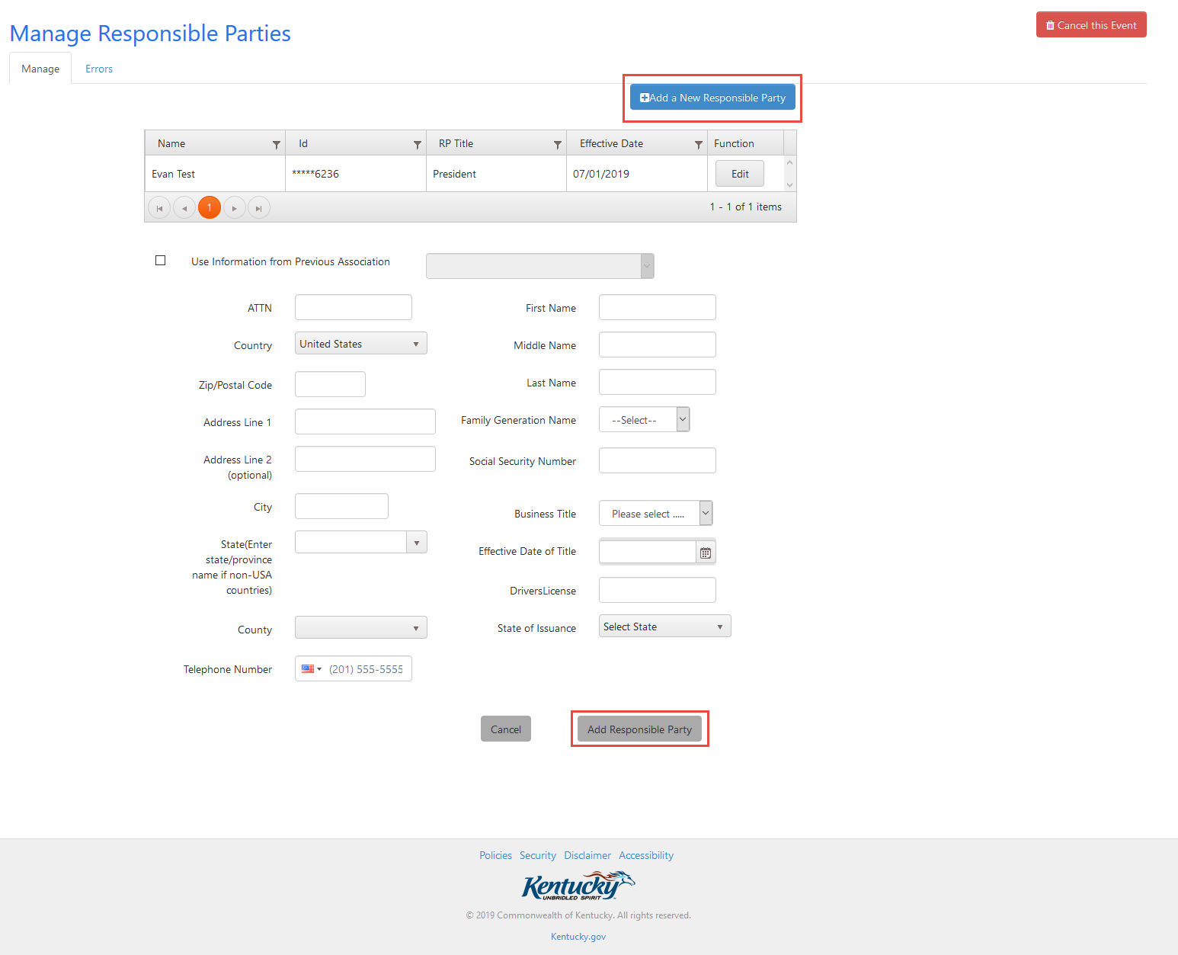

Cigarette/ Tobacco Products Licenses are displayed under the ‘Cigarette/Tobacco Products Licenses’ tab. This tab will be displayed even if the business does not have a license. If they need a license, they can apply for one online by clicking ‘Apply for a License’.

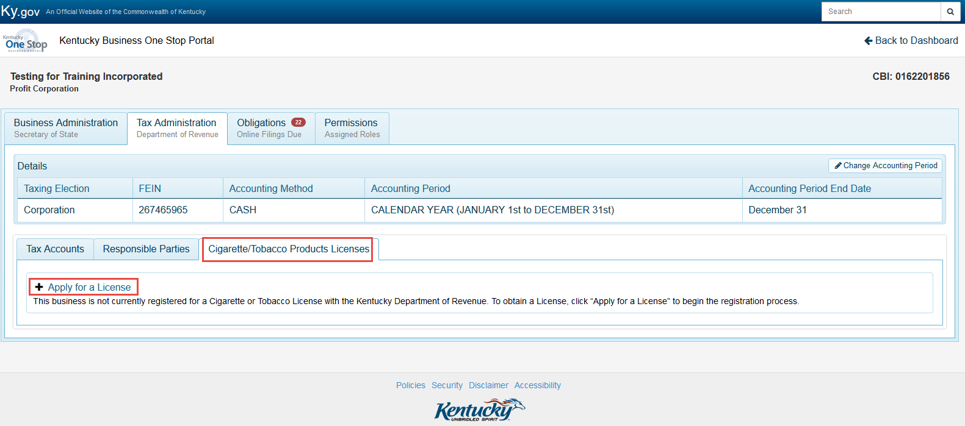

The Obligations Tab provides a snapshot of how many online filings are due. By clicking on the File taxes button the user will be taken to E-file where they can file and pay the return.

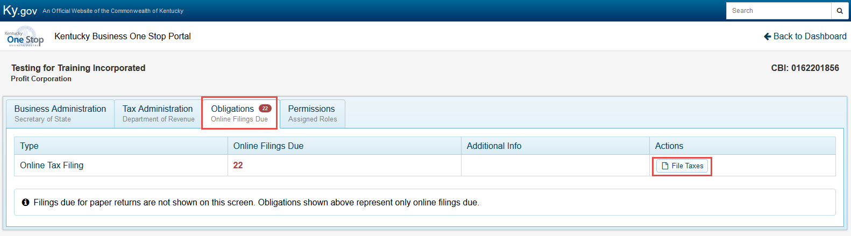

The Permissions Tab lists the assigned roles that a user has for the particular business they are viewing.

